**User Case (Not complete yet)**

1. **Layout**
   1. **Refer to the website below**

[**https://www.mcmaster.com/**](https://www.mcmaster.com/)

* 1. **Search bar on the top**
  2. **Logo (TBD) on the top left**
  3. **Contact Us, BOM, Log In on the top right**
  4. **Choose a Category on the left**
  5. **All Categories takes the main page**

**A mock up layout is like below (for desktop version)**

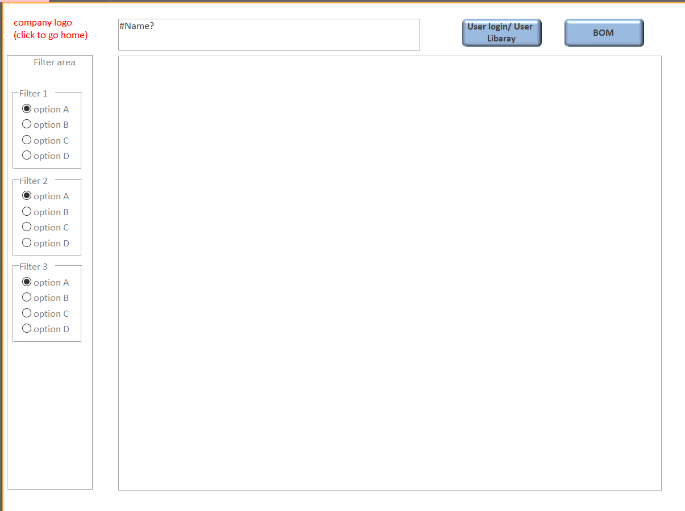

Product information

Search bar

1. **Search**

<https://www.mcmaster.com/>

<https://www.mcmaster.com/power-supplies>

<https://www.mcmaster.com/power-supplies/din-rail-power-supplies-6/>

<https://www.mcmaster.com/power-supplies/din-rail-power-supplies-6/output-voltage~24v-dc/>

(Note: These links are used below. I like the way they organize the above links: main page -> category -> sub category -> part -> filtered part)

* 1. When typing, show results without enter. See Fig. 1.

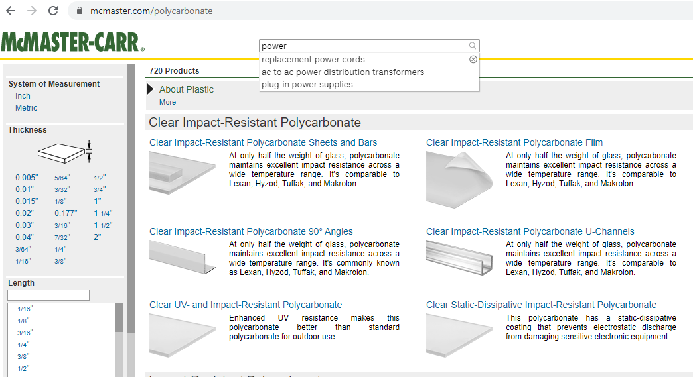

Fig. 1-1

* 1. Writing prompts; see Fig. 1-1
  2. Show the highest category if key words are not specific enough; see Fig. 1-2

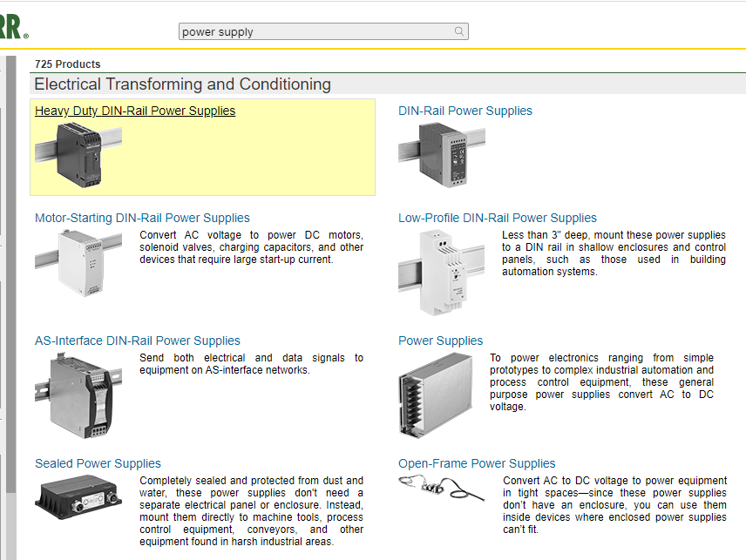

Fig. 1-2

* 1. If search part number, it goes directly to that part and the ADD TO BOM button/page; see Fig. 1-3. (note: I noticed that when type in specific part numbers, the filter bar on the left disappears).

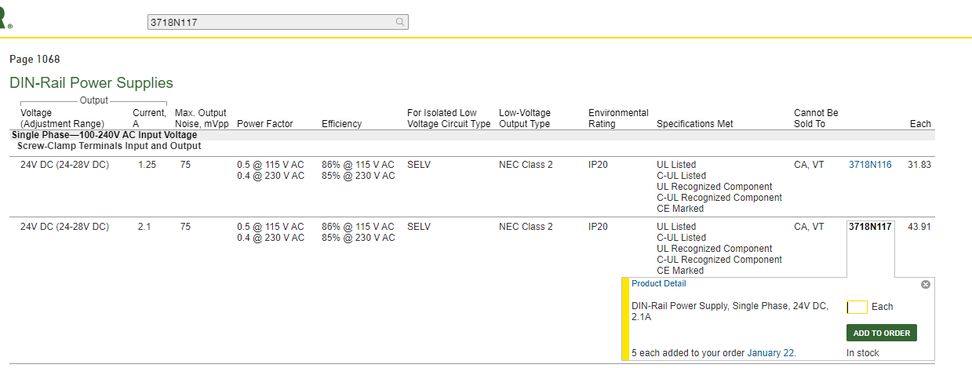

Fig. 1-3

1. **Filter Funtion**

<https://www.mcmaster.com/power-supplies/din-rail-power-supplies-6/>

* 1. Clear all; see Fig 2-1.

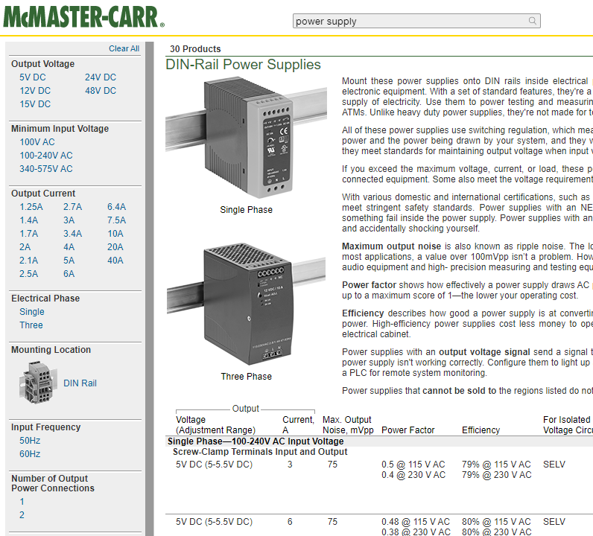

Options

Filters

Fig. 2-1

* 1. Multiple filters; see Fig. 2-1
  2. Under each filter, there are multiple options (Filters and Options are specifications); see Fig. 2-1
  3. May have images; see Fig. 2-1
  4. Show button can show the hidden options; see Fig. 2-2

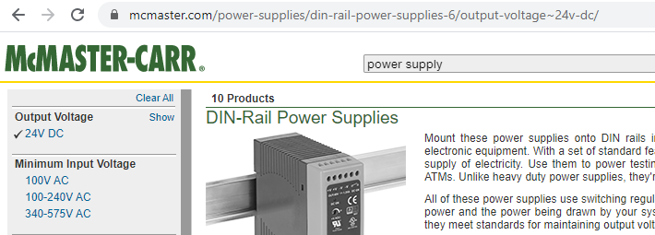

Fig. 2-2

* 1. If there are too many options under a filter to make the page look bad, then show options in the format of list (sliding bar) and with mini search bar on top of each sliding bar; see Fig. 2-3

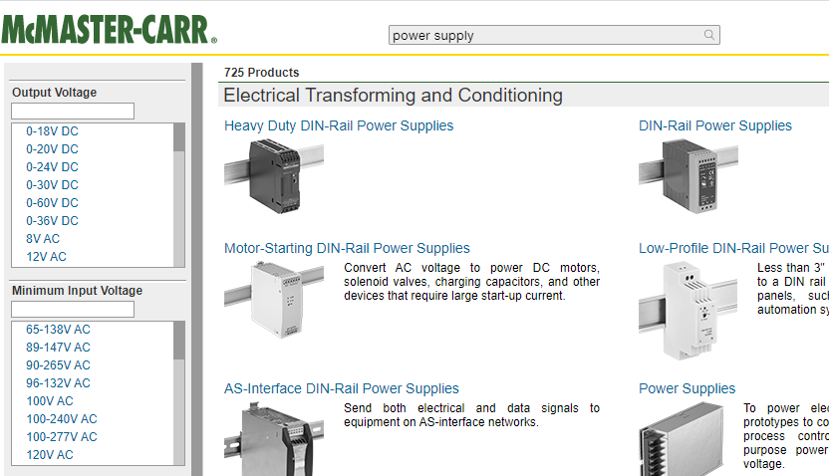

Fig. 2-3

1. Show more button shows more filters; see Fig. 2-4

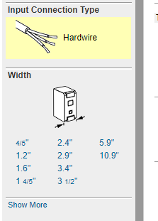

Fig. 2-4

1. **Select parts and add to BOM**

<https://www.mcmaster.com/power-supplies/din-rail-power-supplies-6/output-voltage~24v-dc/>

* 1. Click part number (or the row the part belongs), show a window to set qty; see Fig. 3-1

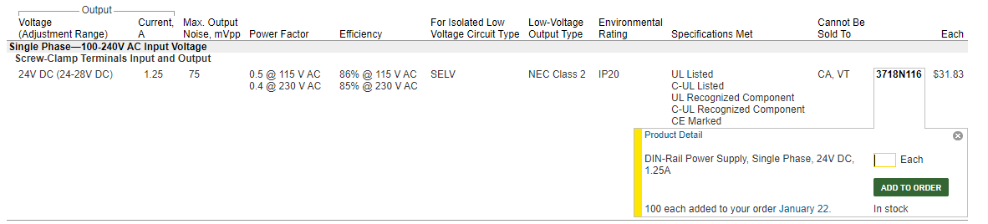

Fig. 3-1.

* 1. Click add to BOM Button (Change ADD TO ORDER to ADD TO BOM), see Fig. 3-1
  2. Show message to confirm the parts have been added; see Fig. 3-2 (message: qty. 10 added to your BOM.

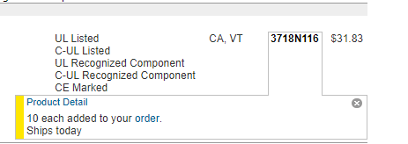

Fig. 3-2

* 1. All product info is shown on only one page; see link below.

<https://www.mcmaster.com/power-supplies/din-rail-power-supplies-6/output-voltage~24v-dc/>

1. **BOM button**
   1. Click BOM button to show the BOM (Change ORDER to BOM); see Fig. 4-1

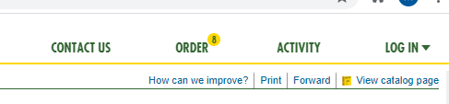

BOM

Fig. 4-1

* 1. BOM will look like this; see Fig. 4-2; no photo is needed on BOM.

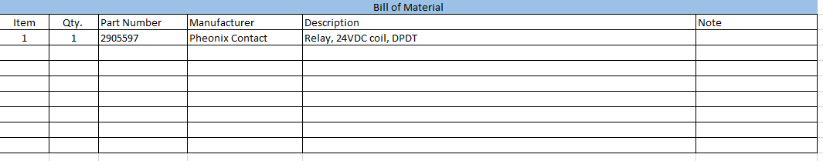

Fig. 4-2

* 1. BOM shows items are duplicated if they are; see Fig. 4-3.

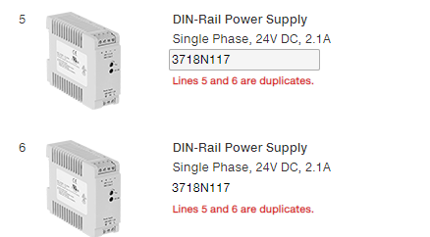

Fig. 4-3-1 (this website has this function)

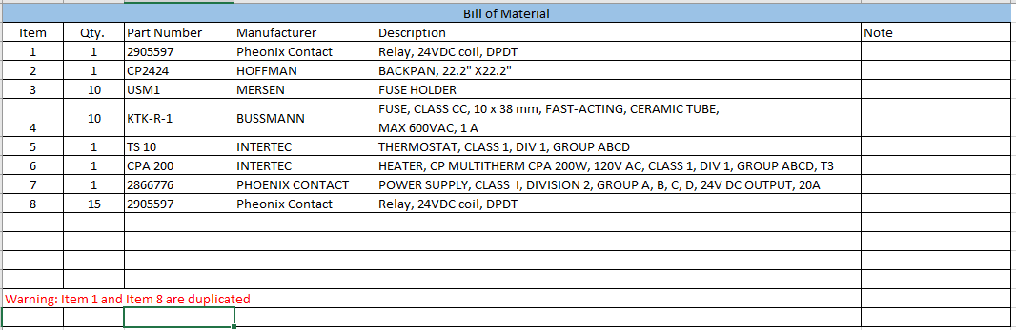

Fig. 4-3-2 (this is what it can look like on our site)

* 1. Add a line button is used to directly add a part if part number is known; Change “Add a line” to “Add a part”; see Fig. 4-4.

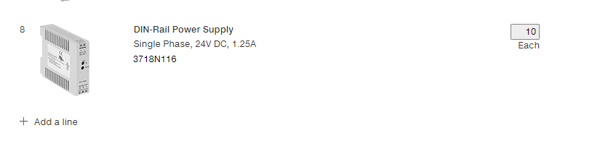

Fig. 4-4

* 1. Top left corner, Project number can be added; see Fig. 4-5
     1. Change Order to BOM
     2. Change “Purchase Order (Optional)” to “Project Number (Optional)”
     3. Add more boxes for information

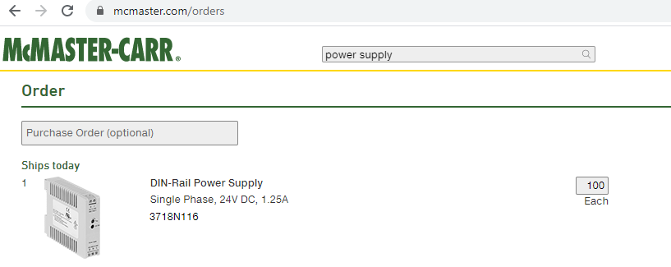

Fig. 4-5

* 1. Save for later button
     1. Change Save your order as to “Save your BOM as”
        1. In the box, add (Project Number, Description, etc.)
     2. Change “Logging in is required to view saved orders” to “Logging in is required to view saved BOM”.

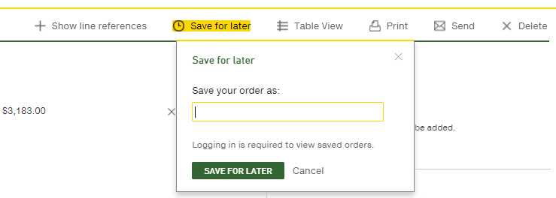

Fig. 4-6

1. User can change the following on the BOM; Fig. 4-7

* Item Number
* Qty.
* Description
* Note
* If the user changes the part number (he knows it), then the manufacturer and Description should automatically get updated.



Fig. 4-7

1. User can hide columns on the BOM; Fig. 4-7

* Item Number
* Qty.
* Part number
* Manufacturer
* Description
* Note

1. User can copy and paste his own BOM from excel to the BOM in our app; Fig. 4-7
2. A share button which allow user to compose an email with the BOM attached as excel file (for web version, it will be a web link).
3. A export button which allow user to download the bom as excel file
   * 1. Naming of the bom file can be projectID+rev+date
4. **User’s personal library**
   1. Purpose:
      1. Help user quickly searches the parts he used in the past
   2. All the parts that user has added to his current or past BOMs, will be automatically stored in User’s personal library
   3. Record the following information for each part
      1. Which BOM this part has been used
      2. Who are the user’s customers that this part was used for
      3. How many times this part has been used (i.e., how many BOMs this part has been added into)
      4. The qty. of the total usage by this user.
      5. Show if the part has been updated or obsoleted.
   4. Previous selected keywords will be shown under the search box when it is empty and selected.
5. **User information collection**
   1. **Assign an internal user ID to each use, independent from its user account number (this is not required for MVP) or any personal information collected from registration.**
   2. **Collect user information includes: searched keywords, selection of existing keywords, selection of options, selection of parts, bom shared, + time stamp of all the operations mentioned.**
   3. **Upload the user information once a week or when program updates (can we add the update function in MVP?)**

**Multiple BOM (ML: not needed yet for Industrial Control Panels; each panel will have each own BOM and will be designed/manufactured individually, even for the same project).**

**Compare BOM’s difference, revision control;**

**Not complete yet. You can Ignore everything from below for now.**